

### Preparation

* Please read the brief carefully.
* Complete the Intermediate Assignment and submit your Looker Studio Report via<https://rebrand.ly/ftda-submit-intermediate>
* **Deadline: Friday, 09:00 AM**

### Introduction of Case Study

You're a data specialist at one of Brazil's rapidly growing online retailers, Samba Commerce. This company offers a selection of over 15k products, spanning across more than 50 distinct categories to customers throughout Brazil. In 2022, various internal and external factors influenced our business expansion. Your expertise is crucial in analyzing these factors.

The CEO, Mr. Ronaldinho, recently tasked Mr. Neymar, the head of the data department, with developing an all-encompassing business dashboard. Mr. Neymar has now entrusted you with this significant assignment.

Mr. Ronaldinho mentioned, *"From our recent team meeting, we've outlined our company's primary OKR (Objectives and Key Results). Mr. Neymar, I want a more in-depth company-wide analysis. This will enable us to gain a clearer understanding of our business operations. Ultimately, our goal is to derive more insightful data to guide our strategies."*

### Dataset

Please use this [Dataset](https://docs.google.com/spreadsheets/d/1ASSOyMsXRkl5Srw3VRk-1Nk_6tZIUDWICd7u_QpvDNk/copy?usp=sharing) (click to make a copy)

### Expected Output

In this assignment, your goal is to craft your own dashboard based on the explanation and dataset above. Here's a sample of the expected output:

**Access the full report** [**here**](https://lookerstudio.google.com/u/0/reporting/4ce94d38-52cc-4cb3-b164-d25ce92b933c/page/p_8homz7swcd)

**Source: Dani Darmawan’s Intermediate Assignment (Student Batch 19 December)**

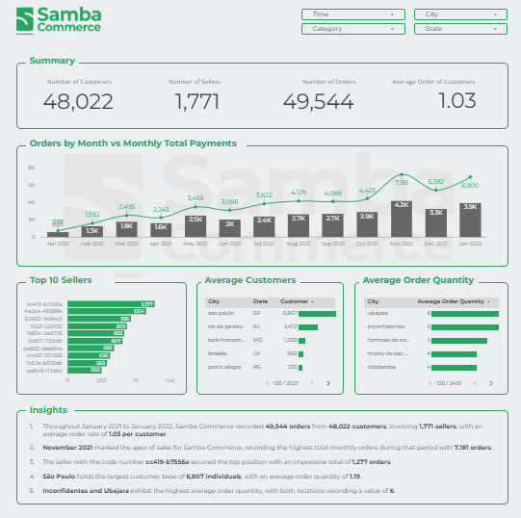

### Instruction

1. Connect and combine /join the above datasets to Looker Studio
2. Create some worksheet visualization of the following:
   1. Using existing field:
      1. Create **Scorecard** visualization that shows **total Number of Customers** (hint: use customer_id)
      2. Create **Scorecard** visualization that shows **total Number of Sellers** (hint: use seller_id)
      3. Create **Scorecard** visualization that shows **total Orders** (hint: use order_id)
      4. Create a **line graph** that shows **total Orders by month** (hint: use Order History table)
   2. Data Filtering and Selection
      1. Identify the **top 10 sellers** based on the number of **total orders** in a **table**
   3. Hierarchical Data Representation
      1. Display data by breaking it down into **Customers' State** and show the total **number of customers** for each with a **bar graph**.
   4. Incorporate Calculated Metrics
      1. Provide a **scorecard** that displays the overall **average order** for **each customer**.
      2. Present a **table** that shows **average order quantity** for each **cities** (hint: calculation of average using qty_item)
3. **Combine the above visualization into one interactive dashboard.**
   1. Dashboards must include flexible periods and other filters, such as: Customer City, Customer State, Product Category, and Order Purchase Time.
4. **Please insert your findings from the dashboard you created (at least 1 insight. The more, the better)**

### **How To Submit Your Report**

* Click on the **"Share" button,** which is typically located in the upper right corner of the report page.
* You will see several options, including "Invite People" and "Get Report Link." **Click on "Get Report Link."**
* Next, set the permission to **"Anyone with the link can view.**" This allows anyone with the link to access and view the report.
* If you encounter any issues with this method, you can also download the report as a PDF file and submit your assignment via Google Drive. **Ensure that your Google Drive folder contains the PDF of your report.**
* Click here to see the video tutorial :[00:54 Link Sharing Feature](https://www.youtube.com/watch?v=7uGfw6sVSF8&t=54s)
* Submit it to<https://rebrand.ly/ftda-submit-intermediate>